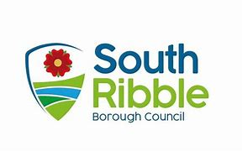

EARLY INTERVENTION & SUPPORT DIRECTORATE

LOCAL GOVERNMENT (MISCELLANEOUS PROVISIONS) ACT 1982

APPLICATION FOR REGISTRATION

1) BODY/EAR PIERCING
2) ACUPUNCTURE
3) TATTOOING
4) ELECTROLYSIS
5) MICROPIGMENTATION (SEMI-PERMANENT MAKE UP)

FEE: £180 for initial registration / £98 (additional person)

Full name and address of Applicant:
Tel No:
Address where business carried on:
Tel No:
Type of business:
Number of Employees:
Is an area set apart from the rest of the business to carry out these operations?
For ear piercing what method is used i.e.. gun or needle?
Means of sterilization used.
Is clean washable overclothing provided?
Means of disposal of soiled and provided used equipment.
Give brief details of experience in connection with the operation applied for.

On receipt of the application a visit will be made to your premises by the Environmental Health Officer to ensure that the arrangements and premises are suitable for Registration.

The Licence fee should accompany this application. Cheques, postal orders should be made out to South Ribble Borough Council and returned to the Public Protection Team, Civic Centre, West Paddock, Leyland, PR25 1DH.

DATA PROTECTION ACT 1988
The information on this form will be used by South Ribble Borough Council under the terms of the Data Protection Act 1998 and will only be used in connection with the operation of the Early Intervention & Support Directorate. In case of query please contact the nominated South Ribble Borough Council Data Protection Officer at the Civic Centre, West Paddock, Leyland, PR25 1DH.

