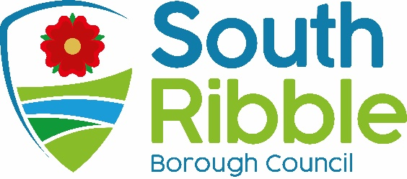
OFFICIAL USE ONLY REFNO.

DATE RECEIVED

Application for street name and/or postal number for new property/new house name

Applicant Name
Company Name
Address

Email address
Phone number

1) Type of Application

New property name (Complete sections 3 and 6)
New street names and postal numbers (Complete sections 2, 3, 4 and 6)
Postal numbers only (Complete sections 3, 4 and 6)
Change of street name/property number (Complete section 5)

2) Suggested Street Names

1
2
3

Reasons for suggested names

3) Development

Location of development
Suggested property name (subject to approval)

4) Type of development
New Build
Conversion

Planning permission reference

5) Change of street name

Current street name
Proposed street name
Reason for request

6) Please enclose the following

Location plan (1:1250)

Showing the application area edged in red

Site layout plan (1:500)

To show plot layout, plot numbers and access points into individual properties (for new developments only)

Please return the form by post to: Building Control, South Ribble Borough Council,
Civic Centre, West Paddock, Leyland, PR25 1DH

Alternatively, you can return the form via email to snan@southribble.gov.uk in either case please ensure that the appropriate plans are attached. Please read the guidance notes in conjunction with completing the form.

All postal addresses are allocated in accordance with BS7666 (2006)

