OFFICIAL USE ONLY REFNO.

DATE RECEIVED
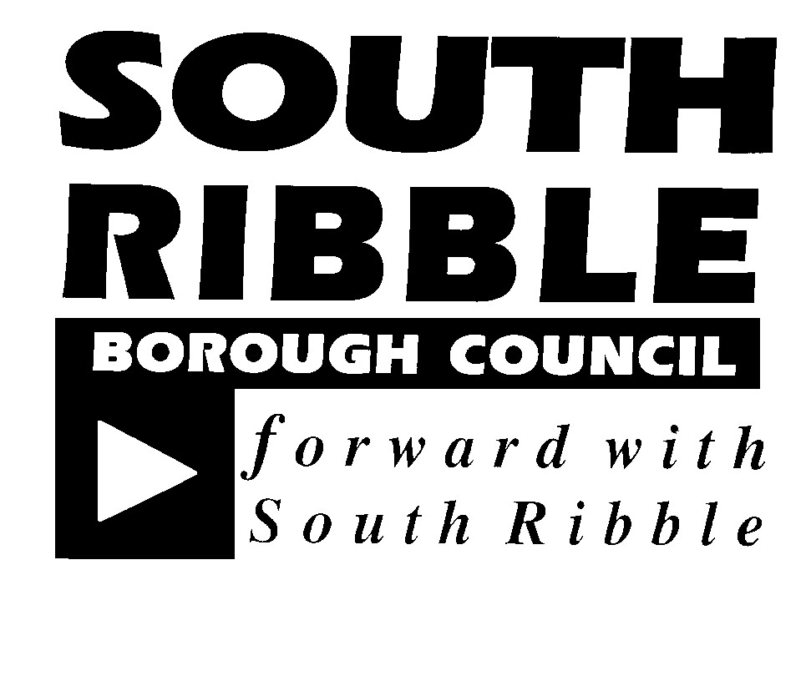

Application for street name and/or postal number for new property

1. Applicant Name

Address

Telephone Number

2. Type Of Application

New street names and postal numbers

Postal numbers only (Go to section 4)

Change of Street Name or property number (Go to section 5)

3. Suggested Street Names

1
2
3

Reasons for suggested names

4. Development

Location of development

Name of development/new building

Type of development

New Build

Conversion

Planning Permission Approval Number

5. If a change of street name or number is requested, please complete this section

Current Street Name

Proposed Name

Reason for request

6. Please enclose the following:

Location Plan (2 copies)

Site layout plan (2 copies) to show - road layout - plot layout - plot numbers - access points into individual properties

Please return the form by post to the address below or via e mail to snan@southribble.gov.uk.or snn@southribble.gov.uk In either case please ensure that the appropriate plans are attached. Please read the guidance notes in conjunction with completing the form

All postal addresses are allocated in accordance with BS7666 (2006)
Please return the completed form to
South Ribble Borough Council,Building Control,The Civic Centre,West Paddock,Leyland PR25 1DH

