LOGO

[GROUP NAME]: [DATE] REGISTERED CHARITY NUMBER: XXXXXXX

Confidentiality Procedure

- Context
The Data Protection Act 1998 and GDPR Act 2018 give clear rules on how any handling and processing of personal information should be carried out. The Act covers all information which is identifiable and personal, and which can be retrieved, including electronic and hard copy records. Additionally, a review was carried out in 1997 by the Caldicott Committee to investigate the ways in which patients’ information is used within the NHS. The aim was to improve the quality and protection of patient information. The investigation identified 7 Key Principles that organisations should adopt, these are known as the Caldicott Principles (See Figure 1). These principles tie in with the principles of The Data Protection Act 1998.

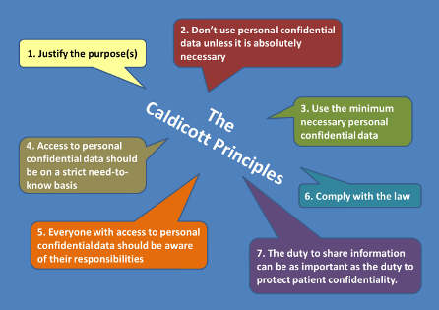
Figure 1: Caldicott Principles

When working with information which is personal and identifiable, [GROUP NAME] staff and volunteers must always apply the Data Protection principles. If you are working in an environment which is covered by the Caldicott Standards eg health and/or social care services, these must also be applied to any personal information that you handle. Appropriate steps must be taken to guard against unauthorised access to, alteration of, accidental loss, disclosure or destruction of data. Simply being aware of the fundamental need for confidentiality and adhering to the following procedures will help you make the right decisions.

- Scope
All paid staff, sessional employees and unpaid volunteers.

- Procedure
[GROUP NAME] recognises that exceptional circumstances may arise in which a breach of confidentiality must be considered. These circumstances are:

- An individual discloses information that raises concerns about their safety, or the safety of others.

- An individual discloses information which must legally be disclosed as not doing so would be breaking the law - eg case notes being subpoenaed to court.

- An individual raises concerns about the safety of a child or vulnerable adult.

- Any recorded information about an individual should be protected. This includes diaries, notes and message books.

- All service users should be informed of their rights under the Data Protection Act 1998 and the procedures in place should they wish to comment or complain about the service.

- Only request, record and store the information that is legitimately required.

- It is not acceptable to hold information unless you have a knowledge of how it will be used.

- Use clear and legible handwriting.

- Explain all abbreviations used.

- Stick to facts and refrain from using personal opinions, judgements and comments.

- Do not discuss individual cases at inappropriate venues.

- Always keep confidential documents locked away.

- All electronic documents eg reports, should be password protected.

- Under no circumstances should you divulge your password to anyone else other than your line manager(s) or other approved staff.

- Under no circumstances should you gain access or attempt to gain access to information stored electronically which is beyond the scope of your authorised access level.

- Unless you are emailing internally within [GROUP NAME] or a professional directly involved in a case, it is good practice to use client initials rather than disclose a client’s name in email communications.

- Always log out of your computer if you are away from [GROUP NAME] offices even for a short period of time,

- Do not leave confidential information unattended on your desk if you are away from [GROUP NAME] offices even for a short period of time.

- When working from home, ensure that information is accessible to no-one but you.

- If cases are to be discussed outside of the [GROUP NAME] team with anyone other than a professional directly involved in a case, always ensure clients remain anonymous.

- Client files and other related confidential information should not leave the office.

- All client data should be pseudonymised to ensure no client can be recognised from electronic sharing of data or paperwork including case studies and reports. If in any doubt, speak with your line manager.

- Action
If you feel concerned about anything that is disclosed to you, or anything you observe, inform your line manager (or in their absence, a member of the senior management team) as soon as possible, detailing any concerns and the manner in which they were disclosed. A decision whether or not to breach confidentiality will then be made.

- If, following discussion, a decision is reached to breach confidentiality the individual should be contacted (if possible and appropriate) and informed of the decision to breach and the course of action to be taken by [GROUP NAME].

- If a client begins to make a disclosure you should inform them that it is possible that you may need to breach confidentiality following discussions with your line manager.

- Contact the relevant department that is responsible for the area in which the individual is living ie Social Services Safeguarding Adults or Community Mental Health Team etc.

- Provide the individuals name, date of birth, contact information and detail any relevant circumstances, eg the nature of the concern and a factual report of what has been disclosed. Do not give opinion or offer to undertake further investigation.

- In any situation where a breach of confidentiality has been considered, the staff member should record details of all discussions and outcomes in clients’ case notes.

- It is not the responsibility of any member of [GROUP NAME] to make judgements, take statements/ask questions of the client, complete multi agency referral forms or to share details of the breach to outside services.

