complaints procedure
[GROUP NAME]: [DATE] REGISTERED CHARITY NUMBER: XXXXXXX
LOGO

- Context
[GROUP NAME] aims to provide a reliable and quality service to everyone. Anyone unhappy with the service we provide has the right to request a copy of the [GROUP NAME] document “Guide to Making a Complaint”.

All complaints will be taken seriously, and everything will be done to make sure the problem is solved satisfactorily. Complaints will be treated in the strictest confidence.

- Scope
All service users, paid staff, sessional employees, unpaid volunteers or students.

Anyone can make a complaint to us, including the representative of someone who is dissatisfied with our service. Please also see the section on ‘Getting help to make your complaint’.

If individuals are unhappy with the services we provide, or with the actions of any member of our team they have the right to request make a complaint.

All complaints will be taken seriously, and everything will be done to make sure the problem is satisfactorily resolved. Complaint will be treated in the strictest confidence.

- Timeframe to Make a Complaint
Normally, a complaint should be made within six months of:

- The event the individual wishes to complain about, or

- Finding out that the individual has a reason to complain, but no longer than 12 months after the event itself.

In exceptional circumstances, we may be able to accept a complaint after the time limit. If the individual feels that the time limit should not apply to their complaint, they must tell us why.

- Procedure
In the first instance, individuals have the option to speak directly to a member of staff who will try to resolve the issue immediately.

Individuals may be unable, or reluctant, to make a complaint themselves. We accept complaints from the representative of a person who is dissatisfied with our service.

We can take complaints from a friend, relative, or an advocate, if they have been given consent to complain for the individual.

If individuals feel that the issue cannot be resolved informally then they can make a formal complaint. This is done by:

- Sending the complaint in writing as soon as possible after the incident and with as much detail as possible.

- Specify the area, service or resource to which the complaint applies.

- Provide their name and contact details. Anonymous complaints will not be investigated.

- Provide a precise outline of the complaint including, if applicable, date and time of incident and name(s) of person(s) involved.

- Indicate if the complaint has previously been reported and whether any action was taken.

- Complaints should be marked PRIVATE AND CONFIDENTIAL and sent it to:

The Chair of Trustees, (GROUP NAME and Address)

If the complaint is against the Chair of the Board of Trustees, it should be sent to the Board of Trustees at the same address.

- Handling a Complaint

Stage One
- Complaints will be acknowledged, in writing, by the appointed Investigating Officer within one week. The acknowledgement will state who is dealing with the complaint and when a full response should be expected.

- A copy of the “[GROUP NAME] Guide to Making Complaints” will be issued with the acknowledgement. A copy of this Guide is shown at the end of this Procedure.

- Individuals will receive a final reply within four weeks. If this is not possible because, for example, an investigation has not been fully completed, a written progress report will be sent with an indication of when a full reply will be given.

- The reply will describe the action taken to investigate the complaint, the conclusions from the investigation and any action taken as a result of the complaint.

- If individuals feel that the problem has not been satisfactorily resolved at Stage One, they can request that the complaint is reviewed at Board level. At this stage, the complaint will be passed to the Chair of the Board of Trustees. If the complaint is about the Chair, the complaint will be passed to another Trustee.

Stage Two
- The request for a Board level review will be acknowledged within one week of receiving it, stating the name of the Investigating Officer dealing with the case and when a can reply should be expected.

- Individuals will receive a definitive reply within four weeks. If this is not possible because for example, an investigation has not been fully completed, a progress report will be sent with an indication of when a full reply will be given.

- Whether the complaint is upheld or not, the reply will describe the action taken to investigate the complaint, the conclusions from the investigation, and any action taken as a result of the complaint.

- The decision taken at this stage is final.

- Complaints Procedure Flow Chart

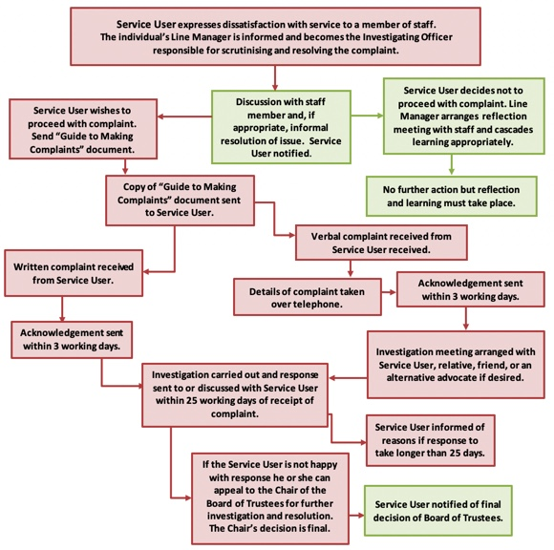

What is a complaint?
We regard a complaint as any expression of dissatisfaction about our action or lack of action.

[GROUP NAME] aims to provide a reliable and quality service to everyone. When something goes wrong, we need you to tell us about it. This will help us to meet your dissatisfaction and to improve our service to all clients.

Who can complain?
Anyone can make a complaint to us, including the representative of someone who is dissatisfied with our service. Please also read the section on ‘Getting help to make your complaint’.

If you are unhappy with the service we provide, or with the actions of any member of our team you have the right to request make a complaint.

All complaints will be taken seriously, and everything will be done to make sure the problem is solved to your satisfaction. Your complaint will be treated in the strictest confidence.

How long do I have to make a complaint?
Normally, you must make your complaint within six months of:

- The event you want to complain about, or

- Finding out that you have a reason to complain, but no longer than 12 months after the event itself.

In exceptional circumstances, we may be able to accept a complaint after the time limit. If you feel that the time limit should not apply to your complaint, please tell us why.

In the first instance, you have the option to speak directly to a member of staff who will try to resolve the issue immediately.

- Your full name and contact details.

- What you feel we have got wrong.

- What you hope to achieve as a result of your complaint.

If you require any help in making your complaint, we will try to help you.

Complaints should be marked PRIVATE AND CONFIDENTIAL and sent it to:

GROUP NAME and address
How We Will Handle Your Complaint

Stage One
- Complaints will be acknowledged, in writing, by the appointed Investigating Officer within one week. The acknowledgement will state who is dealing with the complaint and when a full response should be expected.

- A copy of this document, “Guide to Making Complaints” will be issued with the acknowledgement.

- You will receive a final reply within four weeks. If this is not possible because, for example, an investigation has not been fully completed, a written progress report will be sent with an indication of when a full reply will be given.

- The reply will describe the action taken to investigate the complaint, the conclusions from the investigation and any action taken as a result of the complaint.

- If you feel that the problem has not been satisfactorily resolved at Stage One, you can request that the complaint is reviewed at Board level. At this stage, the complaint will be passed to the Chair of the Board of Trustees. If the complaint is about the Chair, the complaint will be passed to another Trustee.

Stage Two
- The request for a Board level review will be acknowledged within one week of receiving it, stating the name of the Investigating Officer dealing with the case and when a can reply should be expected.

- You will receive a definitive reply within four weeks. If this is not possible because for example, an investigation has not been fully completed, a progress report will be sent with an indication of when a full reply will be given.

- Whether the complaint is upheld or not, the reply will describe the action taken to investigate the complaint, the conclusions from the investigation, and any action taken as a result of the complaint.

- The decision taken at this stage is final.

Getting help to make your complaint
We understand that you may be unable, or reluctant, to make a complaint yourself. We accept complaints from the representative of a person who is dissatisfied with our service.

We can take complaints from a friend, relative, or an advocate, if you have given them your consent to complain for you.

